PROJECT DEVELOPMENT PHASE 6
Functional, Security & Regression Testing
Script-Controlled ACL – Restrict Record Access Based on Field Value
Project Details | Values
Date | 30 September 2026
Team ID | SWTID-2026-8983
Project Name | Script-Controlled ACL – Restrict Record Access Based on Field Value
Phase | Phase 6 – Functional, Security & Regression Testing
Maximum Marks | 5 Marks

Team Role | Team Member
Team Leader | NITHYA SREE S
Team Member | RAMASRI D
Team Member | PRATHISHA S
Team Member | MEGALA M
Team Member | MANJARI T

1. Objective
Verify that the ACL correctly permits and denies access and does not break existing application functions.

2. Phase Workflow
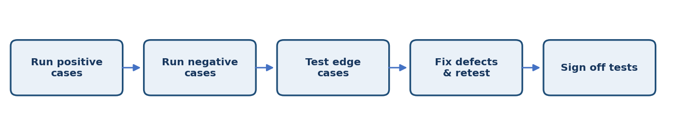

3. Activities / Scope
- Test allowed and denied combinations using non-admin accounts.
- Check list visibility, form opening, and direct record access.
- Test blank, invalid, and changed field values.
- Check relevant related lists, reports, and integrations as applicable.
- Fix defects and rerun impacted tests.

4. Sprint Backlog & Estimation
Sprint | Story ID | Requirement | User Story / Task | Story Points | Priority | Team Members
Sprint 6 | US-601 | Execute access matrix | Test each user type against each field value. | 3 | High | Project Team
Sprint 6 | US-602 | Test edge cases | Verify blank, invalid, and updated field values. | 2 | Medium | Project Team
Sprint 6 | US-603 | Regression testing | Confirm existing approved workflows still work. | 3 | High | Project Team

Total Estimated Story Points: 8

5. Testing / Review Template
Test Case ID | Scenario / Steps | Expected Result | Actual Result | Status
TC-01 | Record expected and actual results for each case. Use non-admin accounts because administrator access may bypass normal ACL behavior. | Expected behavior matches approved requirement. | ________________ | Pass / Fail
TC-02 | Record observations, issues, and evidence for this phase. | No unresolved blocker before phase sign-off. | ________________ | Pass / Fail
TC-03 | Review phase deliverables with the responsible team member. | Deliverables reviewed and approved. | ________________ | Pass / Fail

6. Deliverables
- Completed test-case sheet
- Defect log
- Test evidence and screenshots

7. Team Review & Sign-off
Review Item | Details
Prepared by | Megala M / Project Team
Reviewed by | ____________________________
Approval / Date | ____________________________
Remarks | ________________________________________________

